TRASPOSE

|  |  |
| --- | --- |
| CONVERT TABLE AUX | TO TABLE SALIDA |
|  |  |

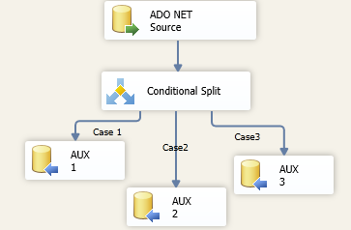

Source, create another 3 columns for the name

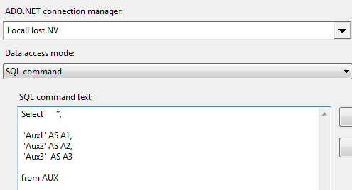

Conditional, set the 3 conditions

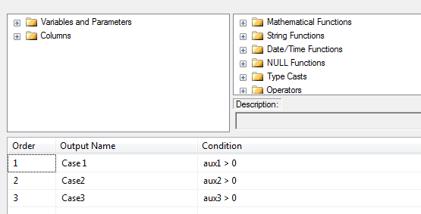

Configuration destiny for AUX1

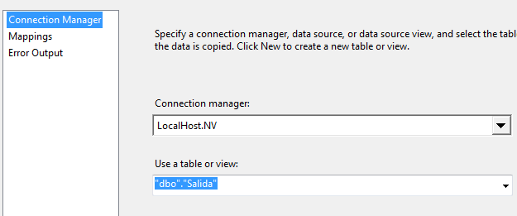

And in the mapping

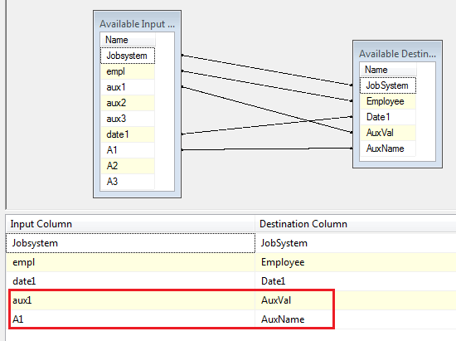

Do the last one for the other 3 fields AUX2 and AUX3